**BUSINESS REQUIREMENTS DOCUMENT**

**PROJECT NAME: MPS – iDeposit On-Call Service Only**

**TFS: 15367**

**REVISION NUMBER: 1.6**

|  |  |
| --- | --- |
| **Project Roles and Responsibilities** | |
| **Business Champion** | **Brent Morris** |
| **Project Requestor / Advocate** | **Brent Morris** |
| **Stakeholders** | **Brent Morris** |

Contents

1 Purpose 3

2 Business Design 3

3 Requirements 5

3.1 Requirements List 5

3.2 Screen Layouts or Prototypes 7

3.2.1 Create Deposit Screen 7

3.2.2 Confirm Deposit Screen 8

3.2.3 Print Deposit Ticket 10

3.2.4 Report Menu for Non-Brink’s Processed Clients 11

3.2.5 Selection Criteria for iDeposit History Report 11

3.3 Report Layouts 12

3.3.1 iDeposit History Report with added columns for Non-Brinks Processed Clients 12

4 Support Information 12

5 Revision History 14

6 Approvals 14

7 Appendix 14

# Purpose

The business would like to allow the user to schedule a pickup of a deposit via iDeposit as a part of the On-Call model. The scheduled pickup information will be sent to iTrack by a new service.

# Business Design

In order to accommodate the Just-In-Time customers, the following items will be implemented.

* Additions to iCash Cash Admin – Service Units screen (Work Item 15379):
  + New flag *- iDeposit On-Call Service Only* to. This flag will be used to identify On-Call customer locations.
  + Location Cut-Off Time Field –This field will be used to determine the cut-off time for next day service. Default to 11:00 am local time
  + Serviced Processor – Drop Down list of Processors, including Brinks, Unknown and Other – this field will be used to determine the level of reporting for the customer.
* Billing setup – clients are either Fixed day or OnCall billing. Customers can select the next day that is available for delivery.
* When a deposit is created, display a date picker dropdown on the Confirm Deposit Screen with Saturday, Sunday and Christmas disabled.
* When creating a new request for service before the cutoff time,
  + all existing requests for service should be deleted or updated to the new requested Service Date
* When creating a new request for service after the cutoff time,
  + any existing requests for service for the next service day are unchanged
  + any existing requests for service beyond the next service day are updated to the new requested Service Date
  + a new request for service for the selected day of service is created
* Notify the user if any existing dates of service are deleted or rescheduled
* Send each request for service via WCF as a synchronous call
* Create report for non-Brinks process clients
  + If Brink’s is not the Deposit Processor, in place of Date Received and Date Verified, use PickUp Date and Scheduled Delivery Date. (The Scheduled Delivery date will always be PickUP Date +1 day)
* Existing Received Date and Verified Date from iCash will show on existing reports.
* This work item should be release at the same time as work item 15507 – Auto Service for Max Threshold %
* When creating a new request for service before the cutoff time,
  + all existing requests for service should be deleted or updated to the new requested Service Date
* When creating a new request for service after the cutoff time,
  + any existing requests for service for the next service day are unchanged
  + any existing requests for service beyond the next service day are updated to the requested day of service
  + a new request for service for the selected day of service is created

# Requirements

# Requirements List

|  |  |
| --- | --- |
| **Req ID** | **Requirement Description** |
| **1.0** | **Modify the Create Deposit Screens for each of these deposits:**  **Create Deposit (Mixed Deposit)**  **Create Cash Only Deposit**  **Create Check Only Deposit**  **Create Foreign Currency Deposit**  **Create Mixed Coin Only Deposit**  **Create Standard Coin Only Deposit**  **Create Change Order Payment Deposit** |
| 1.1 | Add the ability to select a “Requested Pickup date” if customer has On-Call flag activated on the iCash CA Service Units screen |
| 1.1.1 | Add instruction Verbiage to the screens for “Requested Pickup Date” |
| 1.2 | Do not allow the user to select Saturday, Sunday or Christmas for pickup. |
| 1.3 | If it is up to 10:59am local time, allow PickUp date for next available date (not including Sat, Sun or Christmas) – up to 14 days |
| 1.4 | If it is 11:00am or later local time, allow PickUp date for day after next available date (not including Sat, Sun or Christmas) – up to 14 days |
| 1.5 | When creating a new request for service before the cutoff time,   * all existing requests for service should be deleted or updated to the new requested Service Date * a new request for service for the selected day of service is created   (see use cases) |
| 1.6 | When creating a new request for service after the cutoff time,   * any existing requests for service for the next service day are unchanged * any existing requests for service beyond the next service day are updated to the new requested Service Date * a new request for service for the selected day of service is created   (see use cases) |
| 1.7 | Notify the user if any existing dates of service are deleted or rescheduled |
| 1.8 | Update instructions (for On-Call customers for each deposit type)  “Requested Pickup Date: Enter the requested date of service for this deposit” |
|  |  |
| **2.0** | **Modify Confirm Deposit for each of these deposits:**  **Create Deposit**  **Create Cash Only Deposit**  **Create Check Only Deposit**  **Create Foreign Currency Deposit**  **Create Mixed Coin Only Deposit**  **Create Standard Coin Only Deposit**  **Create Change Order Payment Deposit** |
| 2.1 | Add Requested PickUp Date to the top of the iDeposit Ticket beneath the Date |
|  |  |
| **3.0** | **Modify Print Deposit Ticket for each of these deposits:**  **Create Deposit**  **Create Cash Only Deposit**  **Create Check Only Deposit**  **Create Foreign Currency Deposit**  **Create Mixed Coin Only Deposit**  **Create Standard Coin Only Deposit**  **Create Change Order Payment Deposit** |
| 3.1 | Add “Requested PickUp Date:” to the Print Deposit Ticket |
| 3.2 | If deposit is for a customer is not processed by Brink’s – print the following on the Deposit Ticket:  “This deposit is not processed by Brink’s” |
| 3.3 | These changes are to the Print Deposit Ticket screen and to the actual Deposit Ticket that Prints |
|  |  |
| **4.0** | **Send Service Request to JIT site** |
| 4.1 | Use WCF to send Service Request to JIT |
| 4.2 | See appendix for File Layout |
|  |  |
| **~~5.0~~** | **~~Modify Reports Menu for Non-Brinks Processing Clients~~** |
| ~~5.1~~ | ~~If a client does not use Brinks for processing deposits, only show one report option – “Deposit History Report”~~ |
|  |  |
| **6.0** | **Modify Reports – Deposit History Report** |
| 6.1 | Add a “PickUp Date” and “Scheduled Delivery” column to the iDeposit History Report |
| ~~6.2~~ | ~~Create new report for clients that don’t use Brinks processing~~  ~~Clone of the iDeposit History Report with the following fields:~~  ~~Customer~~  ~~Location Name~~  ~~Location #~~  ~~Branch~~  ~~Bag #~~  ~~Date Created~~  ~~PickUp Date~~  ~~Scheduled Delivery (PickUp Date + 1 days)~~  ~~Cash STC~~  ~~Checks STC~~  ~~Coin STC~~  ~~Deposit Total~~ |
| 6.2 | For clients that don’t use Brink’s Processing, the ‘Date Received’ and ‘Date Verified’ fields will be blank and the ‘PickUp Date’ and ‘Scheduled Delivery’ fields will be populated. Clients that use Brink’s Processing will still use the ‘Date Received’ and ‘Date Verified’ fields and the ‘PickUp Date’ and ‘Scheduled Delivery’ fields will be blank.  The report will have the following columns:  Customer  Location Name  Location #  Branch  Bag #  Date Created  Date Received – will not be populated for clients that are not processed by Brink’s  Date Verified – will not be populated for clients that are not processed by Brink’s  PickUp Date – will only be populated for clients that are not processed by Brink’s  Scheduled Delivery (PickUp Date + 1 days) – will only be populated for clients that are not processed by Brink’s  Cash STC  Checks STC  Coin STC  Deposit Total |
| ~~6.3~~ | ~~Add ‘Picked up Date’ From and To to the Selection criteria screen for the iDeposit History Report~~ Note – no change to the selection criteria screen, non- Brink’s processor clients will need to search by Created Date. |
| 6.4 | Only include information for clients that are not processed by Brink’s in the Deposit History Report. Note: this means that the other reports will not have information for clients that are not processed by Brinks. |
| **7.0** | **Systems Available** |
| 7.1 | The system will check for connectivity to iTrack and verify iTrack is running via a web services call when the user clicks on Submit on the Create Deposit screen if the selected location is an On-Call customer  If system is available, display the selected Create Deposit Screen  If system is not available, display an “System Unavailable –Try Again Later” message |
| 7.2 | The system will check for connectivity to iTrack and verify iTrack is running via a web services call when the user clicks “Submit Deposit” on the Create Deposit screen if the selected location is an On-call customer  If system is available, display the selected Create Deposit Screen  If system is not available, display an “System Unavailable –Try Again Later” message |
| **8.0** | **iCash CP update** |
| 8.1 | An update will be made in iCash CP to display a message if a bag is processed for a Non-Brink’s customer “This is not a Brink’s processed deposit. Please created new routing and send to correct processor” |
| **9.0** | **Void Deposit** |
| 9.1 | Add verbiage to the Void Deposit confirmation popup –  “Voiding the deposit may impact your delivery schedule and you may be charged for previously scheduled service.” |

## Screen Layouts or Prototypes

# Create Deposit Screen

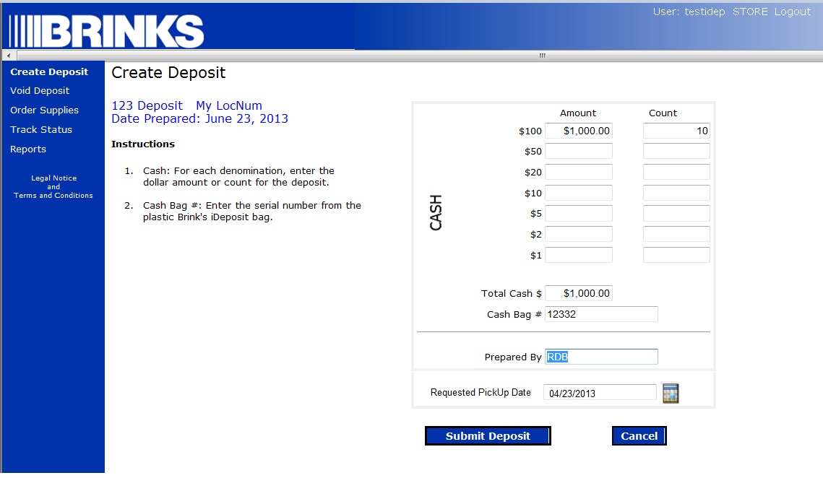

Requested PickUp date only displays if Customer Location has iDeposit On-Call Service Checked on the Service Unit page.

# Confirm Deposit Screen

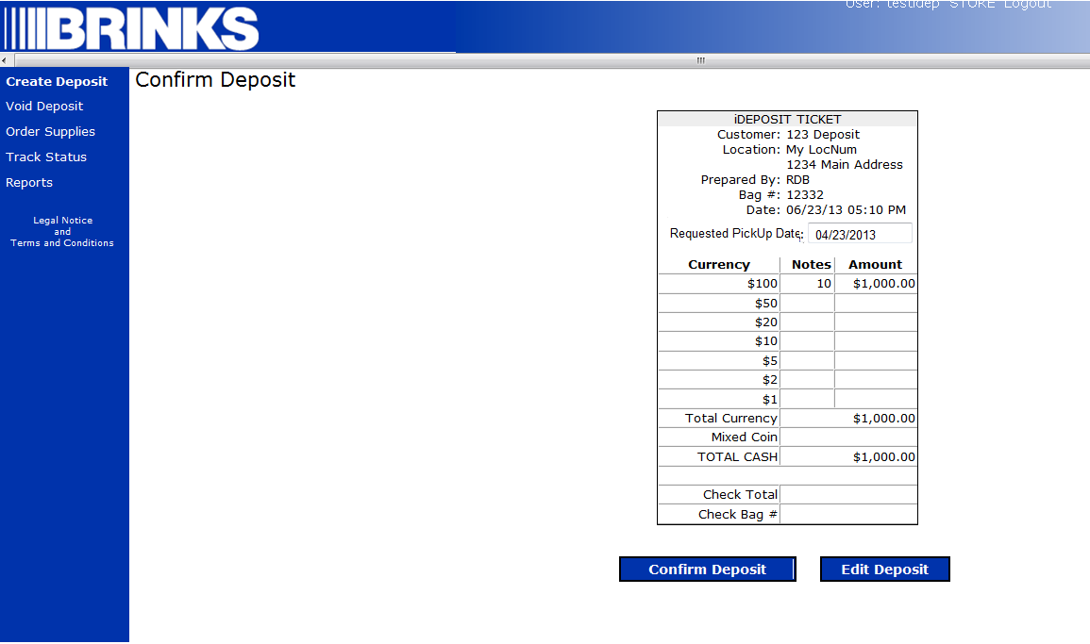

Requested PickUp date only displays if Customer Location has iDeposit On-Call Service Checked on the Service Unit page.

# Print Deposit Ticket

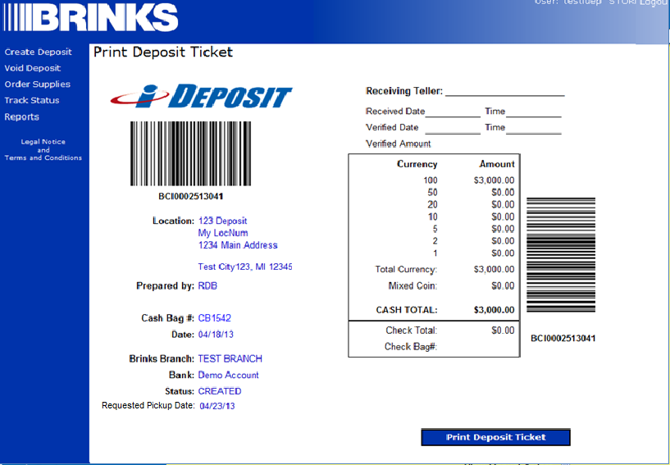

Requested PickUp date only displays if Customer Location has iDeposit On-Call Service Checked on the Service Unit page.

# ~~Report Menu for Non-Brink’s Processed Clients~~

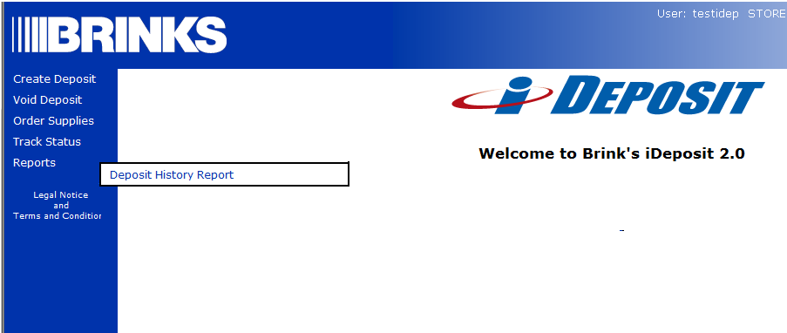

All the reports will be displayed in the menu. If the customer is not processed by Brink’s, the data will not be shown.

# ~~Selection Criteria for iDeposit History Report~~

Not changing the selection criteria.

# Deposit ticket for Non-Brink’s Processed client.

# 

## Report Layouts

# iDeposit History Report with added columns for Non-Brinks Processed Clients

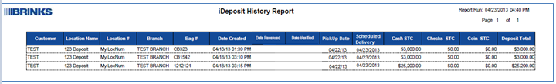

# Support Information

* 1. **Assumptions**
* Work Item 15379 – Add iDeposit On-Call Service Only Fields to Service Unit Screen will be completed before or in conjunction with this work item.
  + New flag *- iDeposit On-Call Service Only* to. This flag will be used to identify On-Call customer locations.
  + Date Field – Location Cut-Off Time. This field will be used to determine the cut-off time for next day service. Default to 11:00 am local time
  + Serviced Processor – Drop Down list of Processors, including Brinks, Unknown and Other – this field will be used to determine the level of reporting for the customer.
* Work Item 15492 – iDeposit – Auto Service Created for Threshold will be completed in conjunction with this work item and released at the same time
* Work Item 15507 – MPS iCash CA – add new AUTOPICKUP% for iDeposit Profile Types will be completed in conjunction with this work item and released at the same time
* No changes to iInfo
* No changes to internal iDeposit application
* User will Email or Call customer Care to cancel an order. (Fees will apply)
* The system saves service request, Profile information, location address, preferred pickup date, etc. for use in future reporting in the existing schema.
* ~~The system will send the~~ *~~MPS Branch~~* ~~and address to iTrack which will determine the~~ *~~CIT Branch~~*~~.~~
* The system will not send the MPS Branch. It will send the location address which iTrack will use to find the closest CIT Branch to use for the pickup. (There is only one branch field in the file that sends the request. iTrack expects it to be the CIT Branch)
* A mapping table will be created in a later phase of the project between MPS Branch ID and CIT Branch ID which will be used to send the CIT Branch to iTrack.
  1. **Exclusions**
* There are no known exclusions.
  1. **Systems Impacts**

|  |  |  |
| --- | --- | --- |
| **System** | **Impacted** | **Comments** |
| Currency Processing (CP) | No |  |
| Currency Admin (CA) | Yes | Requested updates to SU Screen and new Deposit Profile item |
| Coin | No |  |
| Oracle EBS | No |  |
| Safe Server | No |  |
| iInfo | No |  |
| iReports | No |  |
| iDeposit | Yes |  |
| iOrder | No |  |
| OrderAdmin | No |  |
| iProfile | No |  |
| iATM | No |  |
| BAMS | No |  |
| Extracts | No |  |
| iTrack | Yes | Request for service will be sent to iTrack via web service |
| HEAT | No |  |
| People Soft | No |  |

# Revision History

|  |  |  |  |
| --- | --- | --- | --- |
| Revision Number | Revision Date | Author | Description of Change |
| 1.0 | 04/22/2012 | Russell Beard | Initial Document |
| 1.1 | 06/06/2013 | Russell Beard | Removed batch service, added WCF processing of service requests |
| 1.2 | 06/21/2013 | Russell Beard | Updated document based on review on 6/20/2013. Updated Requirements to reflect functionality before and after cutoff time, moved Requested Date to Create Screen, added use cases |
| 1.3 | 06/28/2013 | Russell Beard | Updated document after review on 06/28/2013  Updated requirements 1.5 and 1.6 to clarify functionality of requesting service |
| 1.4 | 08/13/2013 | Russell Beard | Updated document after review on 08/12/2013 clarified Deposit History Report requirements, Updated threshold calculation, Updated web services down actions. |
| 1.6 | 08/20/2013 | Russell Beard | Added verbiage to the Deposit Ticket for non-Brink’s processors message and new VOIDing message. |

# Approvals



# Appendix

* 1. **Just In Time Design**



* 1. **Use Cases**

